BRAILLE BOX AUTHORING APP

# EECS 2311

# Group 9

USER MANUAL

JEREMY WINKLER (214 915 854)

NISHA SHARMA (213 251 830)

TYLER THOMSON (215 081 904)

# **TABLE OF CONTENTS**

**0. Version Information**

**1. Initial Setup**

**2. Scenarios**

**3. The Graphical User Interface**

**3.1. Main Menu**

**3.2. Creating a New Scenario**

**3.2.1. The Authoring App**

**3.2.2. Cells**

**3.2.3. Buttons**

**3.2.4. Order**

**3.2.5. Audio**

**3.3. Editing a Scenario**

**3.4. Saving a Scenario**

**3.5. Testing a Scenario**

**3.6. Exiting the Application**

**4. Troubleshooting**

## **0. Version Information**

This is the first release of the application and it’s documentation, more info regarding maintenance, updating, and uninstallation to come in future releases of the product.

## **1. Initial Setup**

After downloading the zipped folder to a known directory on your computer, simply unzip the folder and navigate to the file **AuthoringApp.jar,** double click to launch the initial window. The app is compatible with up to date Windows, Linux/Unix, and macOS computers running the most current edition of java. In addition, the application is compatible for the visually impaired using Screen Readers supported on NVDA, VoiceOver, and ORCA for Windows, macOS, and Linux respectively.

## **2. Scenarios**

For this application, we’ve broken the components of each scenario into “**Cards**”, each scenario is made up of sequences of Cards, which in themselves can consist of a prompt or question, an audio file if wished, and buttons with possible answers and paths to the given question.

## 

## **3. Graphical User Interface**

## 3.1. Main Menu

Upon launching the application, the user will be met with the main menu, from this menu they will be able to create a new scenario, edit a pre-existing scenario, or test run a scenario.

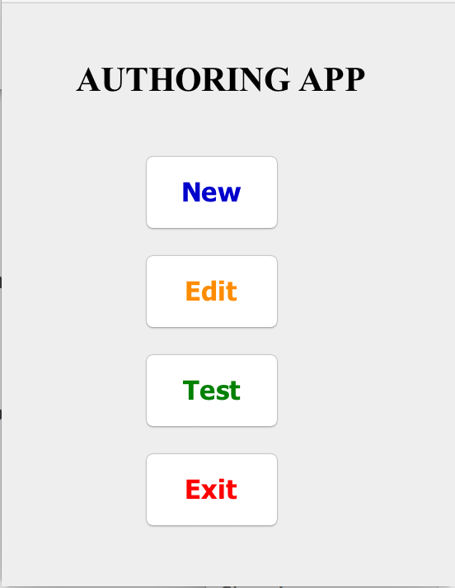

### 

### 3.2. Creating a New Scenario

Upon selecting the “***New”*** option, the user will be given a form from which they can select the **Number of Cells and Buttons** for each card, select the **Scenario Title**, and record **Audio Files** (*For more info on the audio recording interface, see section 3.4*) to add to your library of sounds.

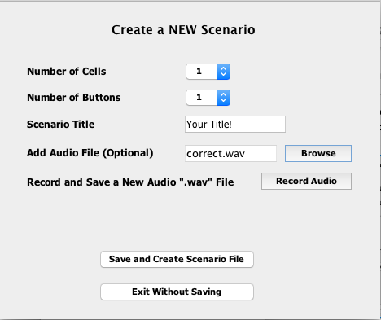

After selecting the details of the scenario, press ***“Save and Create Scenario File”*** to move to the next stage, or ***“Exit Without Saving”*** to return to the main menu.

#### 3.2.1. The Authoring App

Within this window, the user can change the letter to be displayed in the cell, the buttons available to the user and their responses, create or select audio files for the card, and the order the cards shall appear in within the scenario.

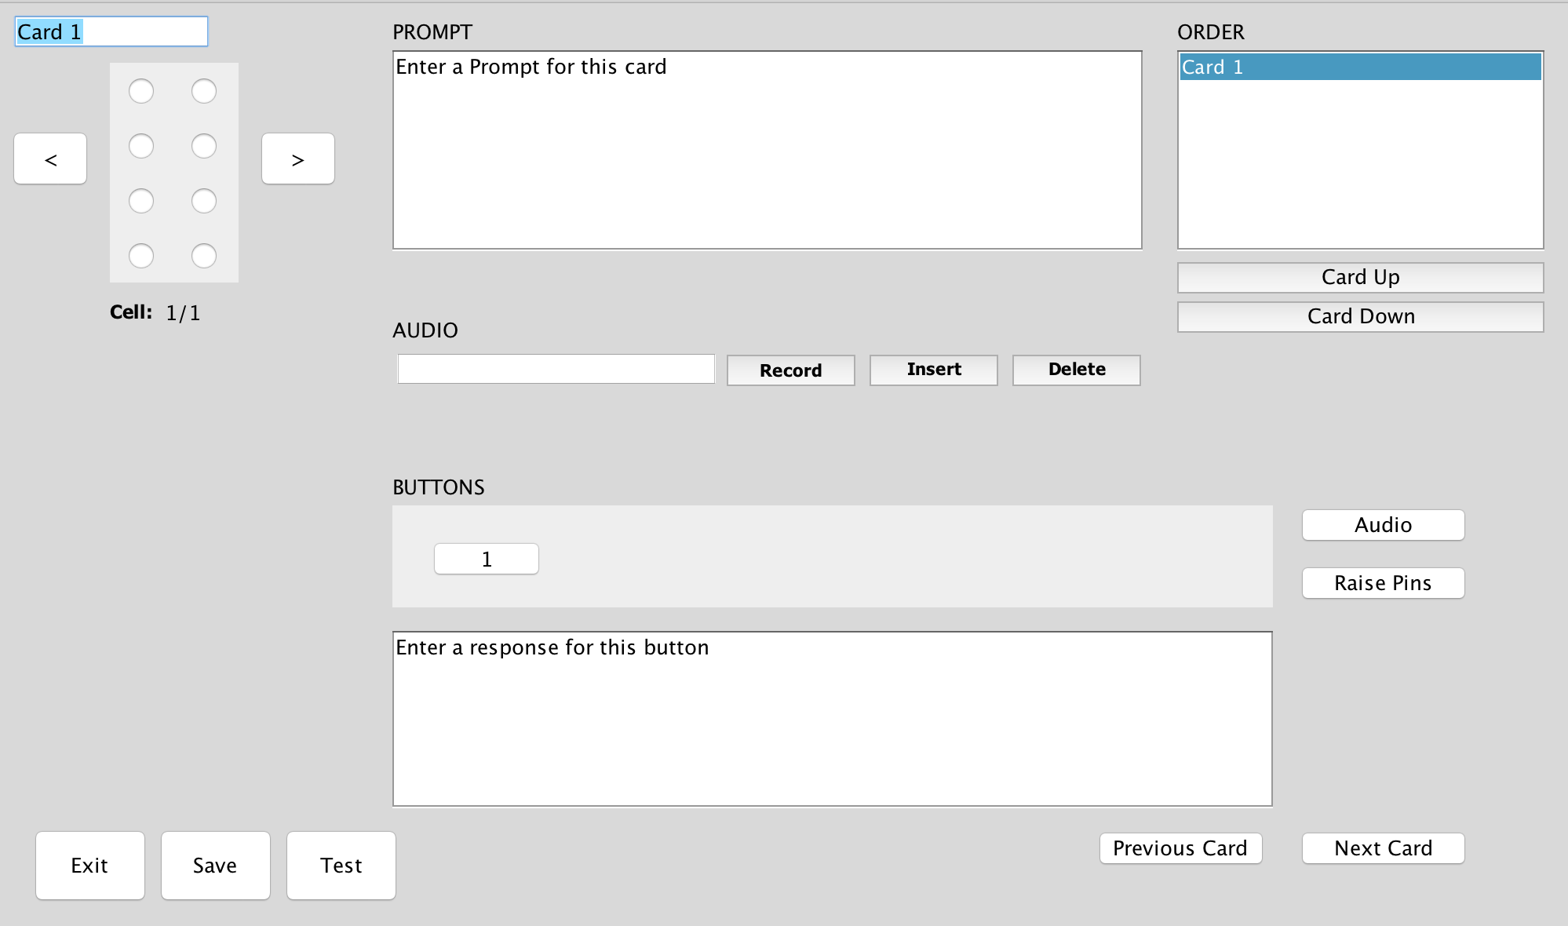

To add new cards, simply press the ***“Next Card”*** button in the bottom right of the window while on the last card within the scenario.

#### 

#### 3.2.2. Cells



To change the letter to be appeared within the Braille Cell, the user need only simply select the respective pins to be displayed from this embedded tool.

#### 3.2.3. Buttons



Within this section of the application it is possible for the user to, for each button, create responses to be read within the text box, the audio clip to be played (***Audio***), and allows the user to select the pins to be raised upon click by providing an 8 character string consisting of 1’s and 0’s for each respective pin (***Raise Pins***).

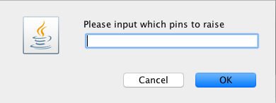

For this current iteration of the application, users can implement functions on button click by manually typing the desired command in the line following the prompt, and with another line between the following text.

|  |  |
| --- | --- |
| **Function** | **Implementation** |
| Skip | /~skip:NEXTT |
| Pause | /~pause:1 |
| Reset | /~reset-buttons |

*Better functionality coming in next update!*

### 

#### 3.2.4. Order



This section allows the user to alter the order from which the cards will be presented to the student. To do so, first select the card to be moved from the list, and press the respective ***“Card Up/Down”***buttons as required.

**Note: The naming card function currently is only in place to allow for ease when reordering the Scenario, these names will NOT be saved. This feature is still under construction.**

#### 

#### 3.2.5. Audio Recording

The following section of the app allows the user to record audio (***Record***), insert a previously recorded clip (***Insert***), or remove the currently selected audio clip from the card (***Delete***)***.***

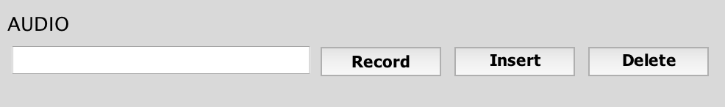

When the user is recording audio, they will be met with the following window, from which they can record audio clips to save for use within their project. This current recorder implementation supports the recording, playing, saving, and naming of audio files along with a button for discarding the currently selected file.

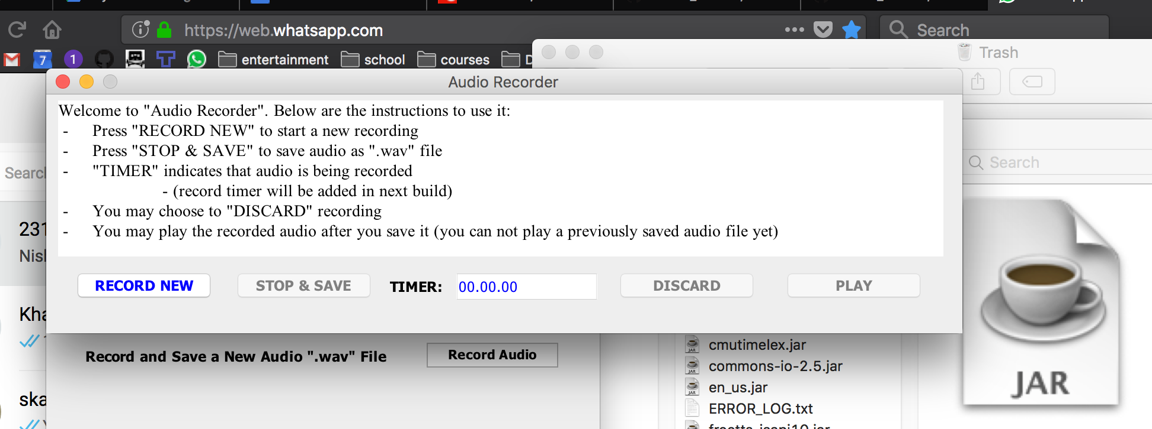

## 

## **3.3. Editing a Scenario**

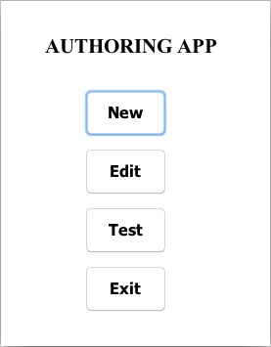

To edit a previously created Scenario, select the ***“Edit”*** option from the main menu, this will launch an iteration of the editing app with the information contained in the selected Scenario available for alteration as necessary.

## 

## **3.4. Saving a Scenario**

## When finished with the currently worked Scenario, select the “***Save***” option from the bottom left of application, and name the Scenario.



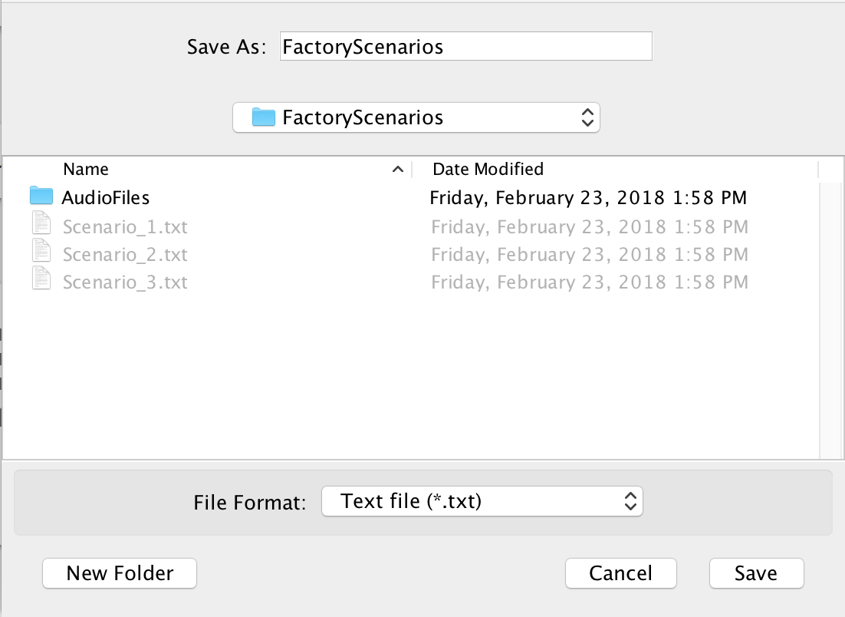

## 

## **3.5. Testing a Scenario**

 *or* 

To ensure the users Scenario runs smoothly, there is a provided ***“Test”*** button within both the main menu, and main authoring window. To test the created Scenario, first *save* the work done, then select this option from one of these windows.

## 

## **3.6. Exiting the Application**

The application does **NOT** save your work upon exit, always be sure to have saved your work using the previously mentioned ***“Save”*** button.



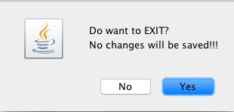

## 

## **4. Troubleshooting**

## If experiencing issues in running the program, ensure the program and edition of Java are up to date on the desired computer, and that all required libraries are contained within the same folder as the AuthroingApp.jar file.

**For further inquiries, please contact the developers.**